
Charles Carroll Barrister Elementary
Monthly Engagement
Tuesday, September 03, 2024

Meeting Focus and Goals:
- Mandatory Reporting
- Committees
- Teacher Evaluation System

Session Outcomes – Participants will:

Topic & Time Frame | Presenter
Welcoming Ritual | Mr. Wunder – Principal
Mandatory Reporter  Child Abuse & Neglect | Ms. Jamison – Social Worker  Ms. Long – Assistant Principal
CCB Action Committees | Konig – Pre-K & K Educational Associate  Rein – Grades 1 & 2 Educational Associate  Johnson – Literacy Coach
Teacher Evaluation Updates | Mr. Wunder – Principal
EGATE | Ms. Propheter – GAL  Ms. Long – Assistant Principal
Green Schools Application Process and Recycling Initiative at CCB | Ms. Bainbridge – STEM Teacher

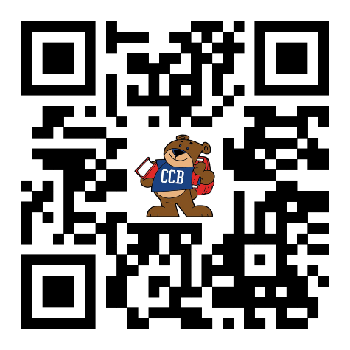
Evaluation

